Name of Student : Raghav Mahesh Sarda PRN: 25070122235
Subject: Programming with Java Semester: III
ASSIGNMENT No : 4 Year: AY 2026-27
TITLE : Wrapper Classes in Java

Problem Statement
Develop a Java application demonstrating the use of wrapper classes for conversion between primitive data types and objects, and performing basic operations on wrapped values.

Learning Objectives
To perform conversion between primitive data types and wrapper objects using Java wrapper classes.

Program:
WrapperStudent.java
// Assignment 4 - Exercise 1: Wrapper class conversion for student marks
import java.util.*;
public class WrapperStudent
{
public static void main(String args[])
{
Scanner sc = new Scanner(System.in);
System.out.print("Enter Subject 1 Marks: ");
String m1 = sc.next();
System.out.print("Enter Subject 2 Marks: ");
String m2 = sc.next();

Integer marks1 = Integer.valueOf(m1); // Converting String to Integer object
Integer marks2 = Integer.valueOf(m2); // Converting String to Integer object

int total = marks1 + marks2; // Auto-unboxing and arithmetic addition
System.out.println("Total Marks: " + total); // Displaying total
sc.close(); // Closing scanner
}
}

EmpPayrollSystem.java
// Assignment 4 - Exercise 2: Employee Payroll System using wrapper validation
import java.util.Scanner;
public class EmpPayrollSystem
{
public static void main(String args[])
{
Scanner sc=new Scanner(System.in);

System.out.println("Enter The Following Details:");
System.out.print("Employee ID: ");
int empid=sc.nextInt();
System.out.print("Basic Salary: ");
double basic=sc.nextDouble();
System.out.print("Bonus Amount: ");
double bonus=sc.nextDouble();
System.out.println("");

double deductions=0.0;
System.out.println("Enter Whether Using New Tax Regime or Old Tax Regime:");
System.out.println("'1' For New Tax Regime");
System.out.println("'2' For Old Tax Regime");
int choice=sc.nextInt();
sc.close();
System.out.println("");

if(choice == 1)
{
deductions = basic * 0.05; // 5% flat tax deduction
System.out.println("New Tax Regime Applied (5% Tax Deduction).");
}
else if(choice == 2)
{
deductions = basic * 0.10; // 10% flat tax deduction
System.out.println("Old Tax Regime Applied (10% Tax Deduction).");
}
else
{
System.out.println("Invalid Input. Select One Tax Slab Please.");
}
// Primitive Type To Wrapper Object
Integer empidobj=empid;
Double basicobj=basic;
Double bonusobj=bonus;

if(empidobj <= 0)
{
System.out.println("Invalid. Employee ID must be greater than 0.");
}
else if(basicobj <= 0)
{
System.out.println("Invalid. Basic Salary must be greater than 0.");
}
else if(bonusobj <= 0)
{
System.out.println("Invalid. Bonus Amount must be greater than 0.");
}
else
{
double net = basicobj + bonusobj + deductions;
System.out.println("\n- Employee Payroll Summary -");
System.out.println("Employee ID: " +empidobj);
System.out.println("Basic Salary: ₹" +basicobj);
System.out.println("Bonus: ₹" +bonusobj);
System.out.println("Tax Deductions: -₹" +deductions);
System.out.println("Net Salary: ₹" +net);
}
}
}

Output:
WrapperStudent.java
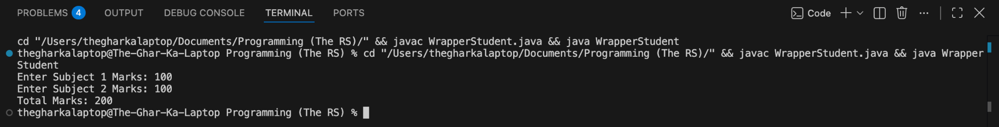

EmpPayrollSystem.java
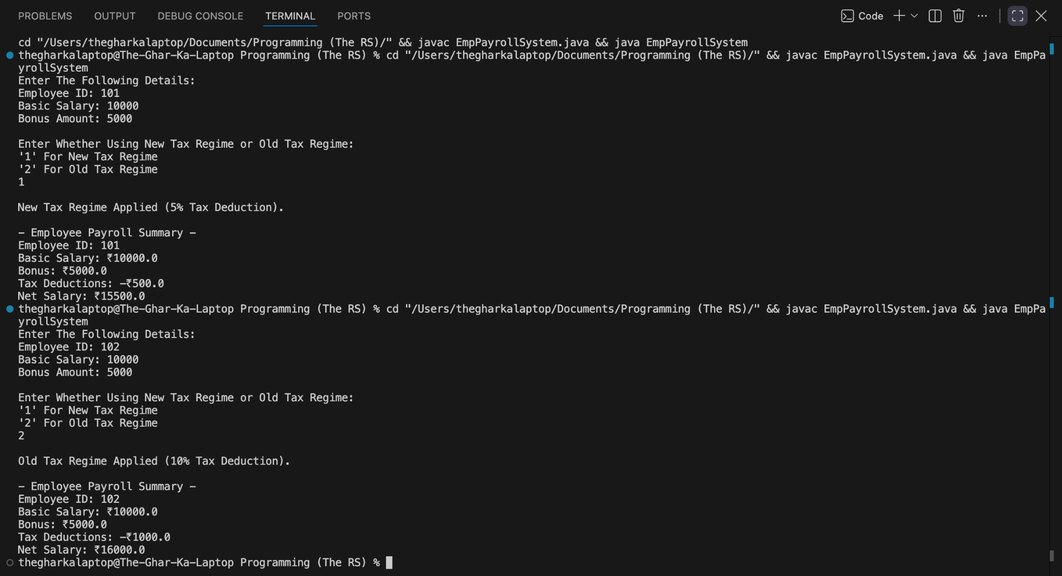

Conclusion:
In this assignment, the concepts of data conversion and object encapsulation using wrapper classes were successfully implemented and verified. Wrapper classes provided reliable mechanisms for parsing string inputs into numeric formats, and autoboxing allowed seamless arithmetic operations between primitive data types and their corresponding object representations.

